

GREENBANK NAA NEWSLETTER

Grey Funnel Dits

*Disclaimer: The material contained in this publication is in the nature of entertainment for the members. Contributions are acknowledged with thanks from service organisations. The editor disclaims all and any liability to any person, whether an association member or not. Views expressed may not necessary be held by the executive or the members.*

A close up of a sign

Description generated with very high confidence

*Editor: Tony Holliday* [*tonyholliday13@gmail.com*](mailto:tonyholliday13@gmail.com) *0403026916*

***Series 7 March 2023 No.3***

***Greenbank Naval Association Subsection***

Events: March 2023

Tuesday 7 March 1900 Normal Meeting RSL Rooms

Wednesday 29 March 1000 Executive Meeting RSL Rooms

Events: April 2023

Tuesday 04 April 1900 Normal Meeting RSL Rooms

Tuesday 25 April 0930 Anzac Day Services

Wednesday 26 April 1000 Executive Meeting RSL Rooms

*********************************************************

***Royal Australian Navy – Personalities***

**Captain D Hamer:**

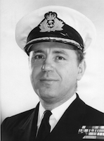**David John Hamer** was born in Melbourne on 5 September 1923 and educated at Geelong Grammar School. He joined the RAN College in 1937 and graduated in 1940 with his colours for rugby and the prizes for mathematics and navigation. He also came first in his class for English and history and was awarded the Grand Aggregate Prize for academic studies and awarded maximum time (four months) for early promotion to Lieutenant. He was promoted to Midshipman in January 1941 and posted to the heavy cruiser HMAS Canberra which served in the Indian Ocean. In November 1941 he joined the destroyer HMAS Napier and served in her in the Mediterranean.

In February 1942 he was appointed to the battleship HMS Revenge operating in the Indian Ocean. Hamer was sent to England to undertake further training courses in May 1942 and was promoted to Sub Lieutenant in August 1942. He excelled on these courses gaining five first class certificates for gunnery, torpedoes, navigation, signals and seamanship. He was awarded the Beaufort and Wharton Prize for navigation and pilotage and the Ian Macdonald Memorial Prize for the signals course. In January 1943 he was appointed to the destroyer HMAS Norman and again served in the Indian Ocean as part of the British Eastern Fleet. He was promoted to Lieutenant in August 1943 and in May 1944 was posted to the heavy cruiser HMAS Australia.

He served onboard Australia as the Air Defence Officer, during her operations in the Philippines at Leyte Gulf in October 1944 and at Lingayen Gulf in January 1945, where he directed the ships anti-aircraft guns against frequent and multiple enemy air attacks. Australia was subjected to repeated suicide aircraft (kamikaze) attacks and despite putting up a heavy barrage of anti-aircraft fire she was hit four times; losing three officers and 41 ratings killed and one officer and 68 ratings wounded. Hamer was awarded the Distinguished Service Cross "for gallantry, skill and devotion to duty while serving in HMAS Australia in the successful assault operations in the Lingayen Gulf, Luzon Island". There is some suggestion in naval circles that Hamer was originally considered for the award of the Victoria Cross for his gallantry at Lingayen Gulf.

In August 1945, Lieutenant Hamer was sent to England to undertake the long gunnery course at HMS Excellent and also saw service at the Royal Naval Air Station (HMS Goldcrest) in Wales during September 1945-January 1946. Upon return to Australia in June 1947 he was posted as Flotilla Gunnery Officer and served in the destroyers HMAS Bataan and HMAS Warramunga. In September 1948 he returned to England to complete the Advance Gunnery Course at HMS Excellent. He returned to Australia in September 1949 and was sent as an instructor to the gunnery school at HMAS Cerberus where he served until December 1950. In January 1951 he was posted to the destroyer HMAS Tobruk and served in her until March 1952 as the Flotilla Gunnery Officer. In April 1952 he was posted to Navy Office, in Melbourne, and served as the Flag Lieutenant Commander to the Naval Board until January 1954. Hamer was promoted to Lieutenant Commander in August 1951.

Lieutenant Commander Hamer joined the cruiser Australia in early 1954 as the Fleet Gunnery Officer and transferred to the aircraft carrier HMAS Sydney in June 1954, in the same role, after Australia was decommissioned. In March 1956 Hamer attended the Royal Navy staff course and was promoted to Commander in June 1956. Upon successful completion of the staff course, he was posted on a two year exchange to the Joint Service Amphibious Centre at Poole in southern England as the Senior Naval Instructor. Upon return to Australia in early 1959 he served at Navy Office in Canberra before being appointed as the Operations Officer to the Flag Officer Commanding the Australian Fleet (serving in the aircraft carrier HMAS Melbourne) in early 1960.

In early 1962 Hamer was promoted to Acting Captain and appointed as the Director of Naval Intelligence in Navy Office and was also an honorary Aide-de-camp to the Governor-General. He was confirmed in the rank of Captain in June 1962. On 2 December 1963, Captain Hamer was posted as the Commanding Officer of the destroyer HMAS Vampire and also commanded the Australian Destroyer Squadron during 1963-65. In July 1965 he took up his final appointment in the RAN as the Director of Project Coordination in Navy Office. Captain David Hamer resigned from the Navy on 1 February 1968 in order to pursue a career in politics.

In 1969, David Hamer was elected to the Australian House of Representatives as the Liberal member for Isaacs (Victoria). He was narrowly defeated by the Labor candidate, Gareth Clayton, in 1974 and became a political columnist for The Age newspaper and undertook a Master of Arts at Monash University in Constitutional Law, studying the historical role of the Australian Senate. He was re-elected to Isaacs in 1975 but contested the Senate in 1977. He was successful and remained a Liberal senator for Victoria until his retirement in 1990. A strong supporter of improving the function of the Senate as a house of review, he was Chairman of Committees as well as Deputy President of the Senate (despite being a member of the Opposition) under the Hawke and Keating Labor governments from 1983-1990.

Hamer was also interested in promoting the arts in Australia, helping establish the Arts Council of Victoria, and serving as President of the Arts Council of Australia and of the Australian Film Institute. He was a keen supporter of the establishment of the National Film and Sound Archive as a way to collect and make accessible Australia's rich audio-visual history. He was also a keen researcher and writer, and his publications include 'The Australian Senate 1901-1918, An Appraisal' (1976); 'Can Responsible Government Survive in Australia?' (1994 and 2004); and 'Bombers versus Battleships - The Struggle between Ships and Aircraft for Control of the Surface of the Sea' (1998).

David Hamer died of leukemia on 14 January 2002. Hamer was also awarded the Queen Elizabeth II Silver Jubilee Medal in 1977 and was posthumously made a Member of the Order of Australia (AM) in June 2002 "for service to the Parliament of Australia, to the recording of Australian military and political history as a researcher and writer, and to the community through arts organisations".

Hamer had two brothers - Sir Rupert Hamer who was the Premier of Victoria 1972-81; and Alan who was a Rhodes Scholar, chemist and businessman. His sister Alison Patrick (née Hamer) was a historian at Melbourne University. In 2004 the Hamer Family Fund was set up in honour of all four siblings and its aims include projects that advance the arts, the environment and good government in Australia.

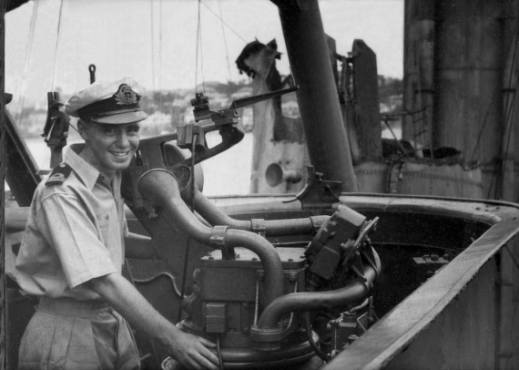

*Lieutenant DJ Hamer, RAN was awarded the Distinguished Service Cross for gallantry, skill and devotion to duty while serving in HMAS Australia during the successful assault operations in the Lingayen Gulf, Luzon Island.*

**Royal Australian Navy – Admirals**

**RADM H J Buchanan:**

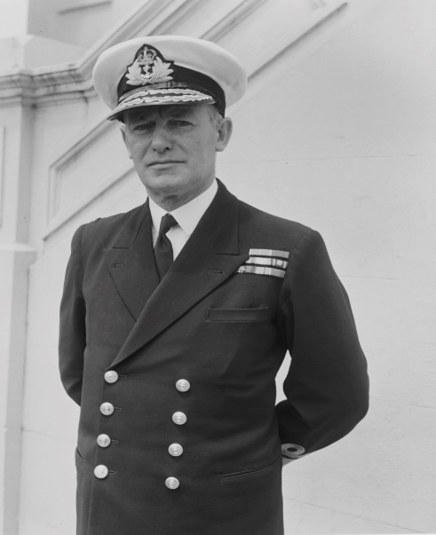**Herbert James Buchanan** was born in North Fitzroy in Melbourne on 10 March 1902 and briefly attended Scotch College before joining the Royal Australian Naval College as a thirteen-year-old Cadet Midshipman in 1916. He remained under training at Jervis Bay until his graduation in 1919 and posting to sea as a Midshipman. He served in a variety of sea appointments during the 1920s and 1930s, specialising in gunnery at HMS Excellent and being promoted Lieutenant in 1924 and Lieutenant Commander in 1932. A man of considerable physical presence and energy, Buchanan soon achieved a reputation as an officer of the highest ability and considerable technical expertise. He demonstrated, too, an impatience with obstacles and interference which made him an excellent practical leader who could achieve good results at sea, but which would make life difficult for himself in higher staff appointments.

On 21 March 1932, Buchanan married Florence Knarhoei Ellis. The two enjoyed a long and happy marriage and had two sons, one of whom was to join the RAN College as a Cadet Midshipman in 1951.

Buchanan was a gunnery officer in the cruiser HMAS Australia in 1935-36, a commission which included service in the Mediterranean during the Abyssinian Crisis. Promoted Commander in 1938 while serving as the Australian Squadron Gunnery Officer, he attended the RN Staff Course at Greenwich in 1939.

The outbreak of the war found Buchanan appointed to the British cruiser HMS Diomede as Executive Officer, but he was soon posted to take up his first command, the newly refitted anti-aircraft escort destroyer HMS Valentine, which commissioned at Devonport on 23 April 1940. With little time to work up Valentine's ship's company soon found themselves in the thick of action as the Germans invaded Belgium, the Netherlands and then swept into northern France. Protecting shipping in support of Dutch forces on the island of Walcheren, Valentine was bombed and sunk by Junkers 87 Stuka dive bombers on 15 May.

Buchanan survived unharmed and was soon sent to take charge of beach control parties during the Dunkirk evacuation. For 'good services' in Valentine and at Dunkirk, Buchanan was Mentioned in Dispatches and also appointed as a Companion of the Distinguished Service Order (DSO). The latter was one of the first to be awarded in the RAN during the Second World War. Buchanan was soon back at sea in command of the destroyer HMS Vanity in which he served until early 1941. In both Valentine and Vanity, Buchanan earned glowing reports from his seniors as a ship captain and, for the first time, was recommended for accelerated promotion.

Buchanan returned to Australia and for two years served as Assistant Director of Plans in Navy Office, Melbourne where he became deeply involved in the development of Garden Island Dockyard, and the Captain Cook Graving Dock, as well as the introduction or radar into the RAN. At times Buchanan’s energy led him into conflict and he became involved in a dispute with the staff of the Australian Squadron’s Commander over the division of responsibilities between the Squadron and Navy Office. Although this problem disappeared with the entry of Japan into the war, the Chief of Naval Staff later shrewdly observed that Buchanan’s lack of tact sometimes introduced difficulties “in his work which would not otherwise arise”.

On 26 May 1943, Buchanan took command of the destroyer HMAS Norman, serving with the British Eastern Fleet. In both Norman and Napier, which he joined on his appointment as acting Captain and Captain (D) Seventh Destroyer Flotilla, he confirmed his reputation as a leader and ship captain second to none. Buchanan worked hard to ensure that Australian ships received adequate logistic support (mail being a particularly vexing issue) and bombarded his superiors with suggestions for improvements in gunnery and radar operations. At the end of 1944 his promotion to Captain was confirmed. Buchanan remained with the N Class destroyers in the Eastern and Pacific Fleets for the remainder of the war and the Japanese surrender found him commanding the Commonwealth elements of the landing force that occupied Yokosuka.

In October 1945 Buchanan was recalled to Navy Office as Deputy Chief of Naval Staff for a year to work under Admiral Sir Louis Hamilton. The two struck up a firm friendship and Buchanan played a leading role in the post-war planning process, particularly in the development of a carrier force and improved anti-submarine capabilities. He returned to sea to command in succession the cruisers HMA Ships Shropshire and Australia.

Buchanan attended the Imperial Defence College course in London in 1949 and then served as a Commodore (Second Class) in command of the training depot HMAS Cerberus until the end of 1952. Here Buchanan found ample space to exercise his talents as a leader with a particular interest in his sailors’ welfare. He was involved in the foundation of the White Ensign Club for sailors on leave and he also enlisted the support of prominent members of the local and Melbourne communities for this and other activities, including the construction of a chapel.

On completion of his command of Cerberus he reverted to the rank of Captain and was appointed in command of the aircraft carrier HMAS Sydney which he took to the Queen Elizabeth II Coronation Review in 1953. He was also created a Commander of the Order of the British Empire (CBE) that year and promoted Commodore (First Class) and appointed as Second Naval Member and Chief of Naval Personnel. He held this responsible billet until early 1955 when he took up the position of Flag Officer-in-Charge East Australia Area. Buchanan remained in this appointment until he retired from the Royal Australian Navy in 1957. Upon retiring, Buchanan received an honorary promotion to Rear Admiral.

Rear Admiral Herbert Buchanan passed away on 15 March 1965.

***********************************

**Royal Australian Navy – Active Ships**

# **Survey Ship, Coastal (AGSC)** HMAS Benalla 11 - HMAS Shepparton 11

HMAS Benalla 11: (AO4) HMAS Shepparton 11 (AO3)

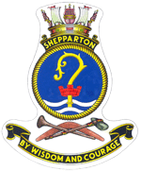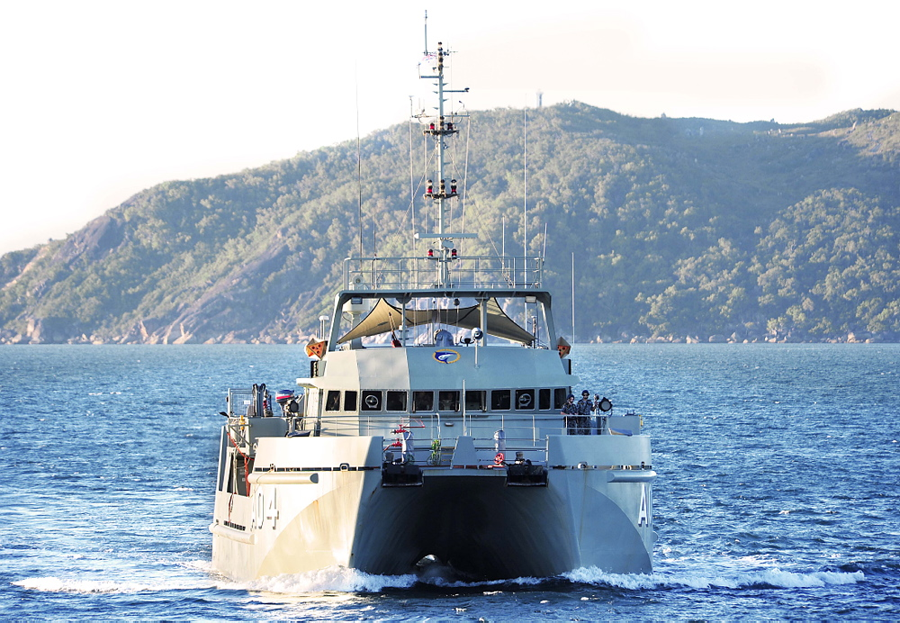

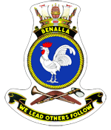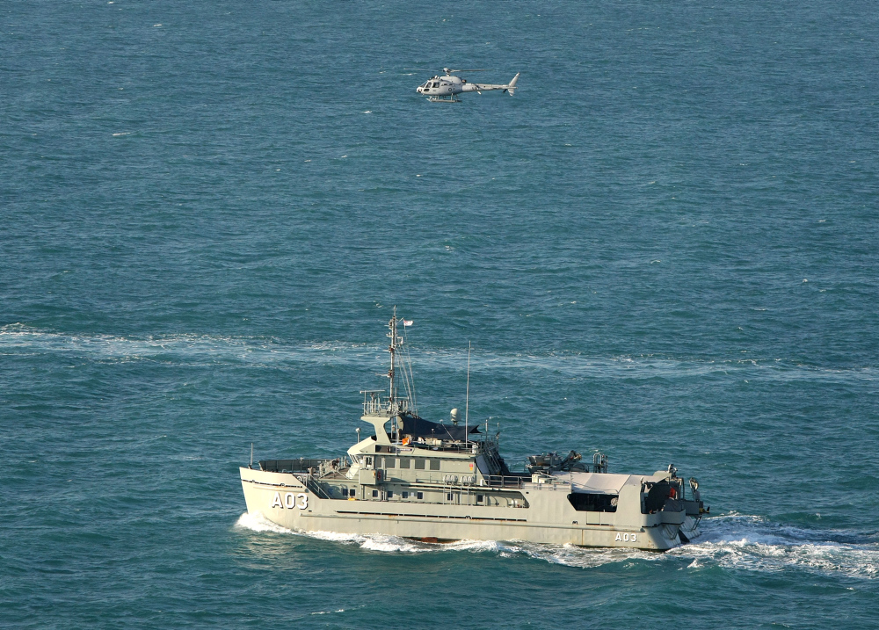

# **Survey Ship, Coastal (AGSC)**

The Royal Australian Navy currently uses the Paluma Class AGSC. Four 360 tonne Survey Motor Launches, HMA Ships Shepparton (II) and Benalla (II), are fitted out for work in shallower and more constrained waters. These ships generally operate in pairs and are designed for operations in the shallow waters of northern Australia. Their twin hulls provide good stability in heavy conditions, along with good living room and space below the main deck. Each Survey Motor Launch carries the latest in survey and computerised hydrographic data processing equipment and is fitted with the latest navigation aids. Following is a list of Surveying Ships Coastal currently commissioned into the Royal Australian Navy.

***Have a laugh.***

There was an elderly couple who in their old age noticed that they were getting a lot more forgetful, so they decided to go to the doctor. The doctor told them that they should start writing things down, so they don't forget. They went home and the old lady told her husband to get her a bowl of ice cream. "You might want to write it down," she said. The husband said, "No, I can remember that you want a bowl of ice cream." She then told her husband she wanted a bowl of ice cream with whipped cream. "Write it down," she told him, and again he said, "No, no, I can remember you want a bowl of ice cream with whipped cream." Then the old lady said she wants a bowl of ice cream with whipped cream and a cherry on top. "Write it down," she told her husband and again he said, "No, I got it. You want a bowl of ice cream with whipped cream and a cherry on top." So he goes to get the ice cream and spends an unusually long time in the kitchen, over 30 minutes. He comes out to his wife and hands her a plate of eggs and bacon. The old wife stares at the plate for a moment, then looks at her husband and asks, "Where's the toast?"

There is a senior citizen driving on the highway. His wife calls him on his cell phone and in a worried voice says, ''Herman, be careful! I just heard on the radio that there is a madman driving the wrong way on Route 280!'' Herman says, ''I know, but there isn't just one, there are hundreds!''

A police officer attempts to stop a car for speeding and the guy gradually increases his speed until he's topping 100 mph. The man eventually realizes he can't escape and finally pulls over. The cop approaches the car and says, "It's been a long day and my shift is almost over, so if you can give me a good excuse for your behaviour, I'll let you go." The guy thinks for a few seconds and then says, "My wife ran away with a cop about a week ago. I thought you might be that officer trying to give her back!"

*************************************

**RAN Shore Establishment History**

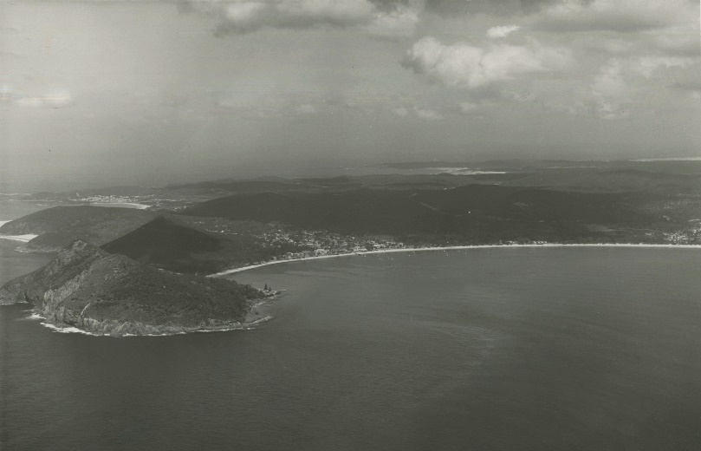**HMAS Assault:**

*Shoal Bay, Port Stephens, NSW*

In March 1942, the Australian Government, recognising the importance of an amphibious capability in any effort to drive the Japanese out of the Pacific, began exploring the requirements for combined operations training in Australia. On 18 March 1942 the Deputy Chief of Naval Staff, Captain Frank Getting, RAN, wrote to the Chief of Naval Staff, Vice Admiral Sir Guy Royle, KCB, CMG, RN “The provision of special equipment and landing craft is being examined by Third Naval Member, and the production capacity of this country will be a consideration…Regarding School of Combined Operations, we know that such a school exists in UK and Commodore Lord Louis Mountbatten, RN, is in command of this school. We know no more about it, except that we assume the raids which have been carried out on enemy occupied territory are planned in this school. I consider it worth while [sic] asking Admiralty for a description of how this school is constituted, and how it approaches the problem.”

The Naval Board subsequently asked the Admiralty for information regarding combined operations training with the express strategic intent of re-establishing the string of island bases to the north and north-east of Australia. The Admiralty proposed to return to Australia Commander Frederick Cook, DSC, RAN, who had been the Commanding Officer of HMS Tormentor, a combined operations shore establishment in the UK, to establish a combined operations training centre in Australia in conjunction with Lieutenant Commander Harold George, RNVR, Lieutenant David Richardson, RANVR, Lieutenant Colonel M Hope (Royal Artillery), Lieutenant Colonel TK Walker (Royal Marines) and Wing Commander AM Murdoch, RAAF, all with combined operations experience. Meanwhile Commander Cook would be relieved at Tormentor by Commander Alfred Buchanan, RAN, who would gain experience in combined operations before also returning to Australia early in 1943. Upon his return, Commander Cook took charge of the Australian Combined Operations Section providing advice to the Commander, Allied Land Forces (General Thomas Blamey) and the Australian Chiefs of Staff on combined operations, and to coordinate the Australian effort.

Navy and Army planners, both Australian and American, began to examine what would be required to establish a combined operations training centre in Australia and what such an organisation might look like. Commander Cook arrived in Melbourne on 3 June 1942 and two days later attended a meeting at the American General Headquarters (GHQ) in Melbourne along with Lieutenant Colonel Hope and Captain Getting. There they were informed of General Douglas MacArthur’s decision to bring combined operations training in Australia under the control of the American GHQ. One Australian and two American divisions were to be trained as soon as possible with the RAN producing one third of the total number of boat crews required and providing the naval requirements for soldiers under training.

On 8 June Commander Cook and Lieutenant Colonel Hope set out on an aerial reconnaissance of the east coast of Australia with the intention of locating a suitable site for a combined operations training centre.

They subsequently made a series of recommendations which included the identification of Port Stephens, north of Newcastle in New South Wales, as the most suitable site for a training centre considering land, sea and air aspects, as well as the Japanese submarine threat at that time. Meanwhile, the Australian Army was pushing ahead with plans to establish training facilities in Queensland. Subsequently, two training centres were established before the end of the year. The Army established the Combined Training Centre at Toorbul Point (now Sandstone Point), Queensland. Meanwhile, General MacArthur ordered the establishment of a training centre at Port Stephens, known as the Joint Overseas Operational Training School, on 9 August 1942 by which time, in anticipation of that directive, the RAN had already conducted a survey of the site and drawn up plans for an establishment providing for 60 officers, 500 sailors and 100 landing craft. The armed merchant cruiser HMAS Westralia (I) was allotted as a temporary accommodation ship and HMAS Ping Wo was detailed as her tender. Nine motorboats were requisitioned for training purposes while construction of landing craft was undertaken in Australian shipyards. At the same time Lieutenant John Band, RANR(S), was detailed to proceed to Toorbul in July, and was joined by a Sub Lieutenant and eleven ratings in August, to establish RAN Station No. 5 and commence training for boat crews.

With construction work progressing ashore at Port Stephens, HMAS Assault was initially commissioned under the command of Commander Cook aboard Westralia on 1 September 1942, two days before the ship even arrived at Port Stephens, and began providing instruction for landing craft crews, beach parties (naval commandos) and combined operations signals teams. However, just six weeks after commissioning, General MacArthur expressed some concern about the distance between the two training centres at Toorbul Point and Port Stephens and asked that alternative sites in Queensland be considered for the Port Stephens establishment.

Toorbul Point was an excellent site for Army training, but sand bars between the site and Bribie Island, and the lack of a sheltered beach usable at all tides meant that it was not well suited to naval training.

After completing surveys of sites at Gladstone, Emu Park, Broad Sound, Mackay, Cannon Valley, Bowen, Townsville, Lucinda Point, Cairns and Innisfail, it was determined that Port Stephens was an ideal site for training naval crews and, also considering the financial outlay already made in developing the site, the decision was made to maintain the school there.

Naval crews would undergo their initial training at Port Stephens after which they could proceed to Queensland to complete their training with Army troops. Commander Cook would later reiterate that the decision to establish the base at Port Stephens was a good one, stating “…the choice of Port Stephens as a Combined Operational Base has proved wise and advantageous as all types of beaches are readily available in the immediate vicinity and the surrounding areas provide plenty of scope for the movement of Army personnel. Steep or shallow sandy beaches, with or without surf are available and rock, mud and mangroves are handy in the bay.”

Assault transferred ashore on 10 December 1942. An American Amphibious Training Group was also established nearby, and the two facilities were combined as the Amphibious Training Centre (ATC) in February 1943 under the overall command of the commander of the South-West Pacific Amphibious Force, Rear Admiral Daniel E Barbey, USN, bringing all combined amphibious training in Australia under American command. Training at Assault from then on included US soldiers and marines, and Australian Army soldiers, as well as RAN personnel. HMA Ships Kanimbla, Manoora and Westralia were all converted to infantry landing ships (LSI) during 1943. Manoora and Westralia made numerous voyages between Port Stephens and Melbourne ferrying American personnel to and fro.

The base was established to accommodate 560 officers and men, but as many as 870 were borne there at its peak, leading to the construction of further accommodation towards the end of 1943. Some 67 buildings were initially constructed of galvanised corrugated iron including a hospital and engineering workshop. To accommodate the large influx of landing craft to the site, boat moorings were laid and the existing jetty was fully reconstructed and extended to a length of 510 feet (155.4m) with an 'L' shaped extrusion of 162 feet (49.4m) which formed the boat compound. A boatshed and slipway were also constructed and completed in August 1943.

The temperate weather meant that the base staff and trainees were, for the most part, in good health, though the arduous nature of the training did see a number of trainees admitted to the hospital with various injuries. The hospital staff also performed emergency surgery on a survivor from a Catalina amphibious aircraft that crashed on 24 May 1943. The Catalina had taken off from RAAF Base Rathmines on Lake Macquarie to examine the suitability of conditions in Port Stephens to conduct training for rough water landing. The aircraft crashed into the sea at Shoal Bay that morning tragically killing seven of its nine crew members. The cause of the crash was never determined.

Training at Assault was intense, covering every aspect of landing operations on hostile shores. Sailors had to partake in assault courses, instruction in various weapons and explosives as well as hand-to-hand combat.

Former naval commando, Able Seaman Ted Jones, recalled training with his unarmed combat instructor, Lieutenant Donald Davidson “Over and over again he would impress upon us that we were being trained to fill a commando role and in such a role we could quite easily find ourselves in a position where we had to depend on our hands, eyes and senses to prevent an enemy in hand-to-hand combat from killing us...it was – kill or be killed – and this was a reality, not a supposition.”

Officially known as ‘beach commandos’, they also had to learn how to conduct in-water surveys of potential landing sites which would often leave them immersed, fully clothed, for hours on end. The beach commandos also became skilled at constructing makeshift metal ‘roadways’ on beaches enabling the landing of vehicles as large as a tank.

Among the officers at Assault was Lieutenant Commander Reg Buller, RANR, who had served in the RAN Bridging Train at Gallipoli in 1915. Lieutenant Commander Buller provided specialist advice on the conduct of amphibious logistics operations in a contested environment.

Only two Australian built landing craft were available through to the end of 1942 which made the proper training of boat crews problematic as, while the requisitioned motorboats gave the crews experience in handling twin screw boats, they were inadequate to instruct in the handling, running and beaching of landing craft in all conditions. The situation began to change on 14 December, however, when sufficient numbers of American landing craft were delivered, and the full gamut of training exercises could be undertaken. The Australian built landing craft began arriving in early 1943 and five of the requisitioned motorboats were returned to Sydney on 10 January for other duties. The training burden was further eased in March when 19 American landing craft were handed over to Assault giving the trainees a wide variety of boats in which to gain experience. 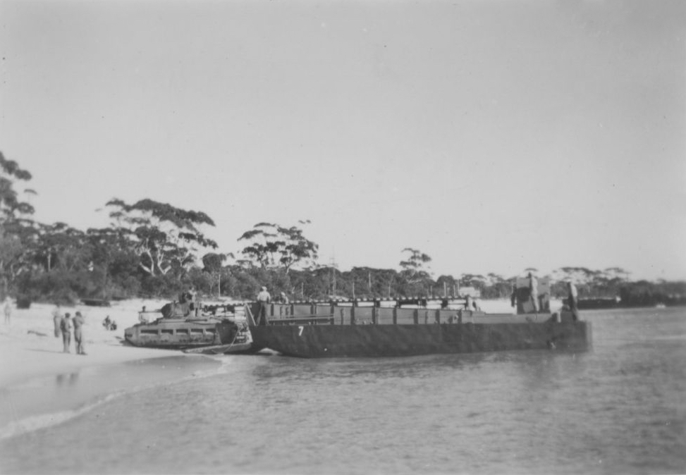

*A Matilda tank rolls off a landing craft at Shoal Bay*.

By the beginning of October 1943 more than 1000 naval personnel had been trained for combined operations at Assault including 100 officers; 100 landing craft coxswains; 120 beach commandos; 40 landing craft signalmen; 453 boat crewmen; and 250 stokers. This was in addition to the 20,000 US soldiers and 2000 Australian soldiers who, although receiving their primary training in the US part of the ATC, had also received training at Assault.

Training of new naval personnel in combined operations ceased at Assault in October and the base commenced what Commander Cook described as its ‘second phase’; to act as a supply and ‘spare’ base for landing craft and a pool depot for a reserve of trained combined operations personnel. Assault also continued to support the ongoing training of US Army personnel in the US section of the ATC. Most of the trained RAN personnel, as well as Kanimbla, Westralia and Manoora, and the majority of the associated landing craft, were transferred to Toorbul. In spite of the large outflow of personnel, ships and boats, Assault remained, initially, a busy establishment with a large number of combined operations trained sailors undergoing continuation training, for which four landing craft were provided by the American Landing Force Equipment Depot.

The number of personnel, both base staff and trainees, rapidly declined in early 1944. by that March even continuation training had ceased, and the future operation of Assault was under consideration by the Naval Board. On 4 August the base was reduced to a ‘care and maintenance’ basis with a complement of one officer and twenty-four ratings.

Assault was decommissioned on 7 April 1945 and transferred to the Royal Navy as a depot for the British Pacific Fleet.

**\*\*\*\*\*\*\*\*\*\*\*\*\*\*\*\*\*\*\*\*\*\*\*\*\*\*\*\*\*\*\*\*\*\*\*\*\*\*\*\*\*\*\*\*\*\*\*\*\*\*\*\*\***

**Brief History – RAN Reserve**

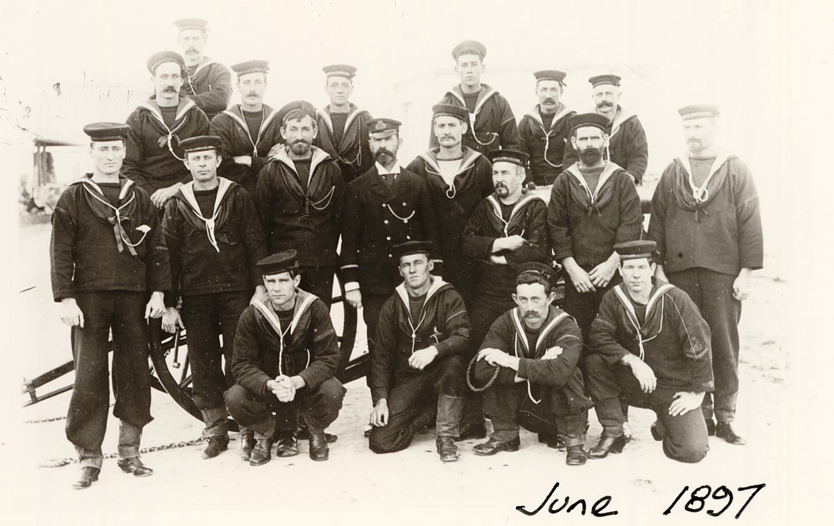

The Royal Australian Naval Reserves (RANR) can trace its origins back to at least 1863 and the formation of the New South Wales Naval Brigade. By 1884 most of the Australian colonies had established volunteer citizen reserve Naval Brigades, their fortunes waxing and waning in accordance with the financial and political interest displayed by colonial administrators. The Commonwealth assumed overall responsibility for these forces at Federation, at which time their strength numbered 1684. However, with federal policy primarily relying on the Royal Navy to provide for naval defence needs, the State-based forces languished with few resources and declining numbers. As part of the 1903 Naval Agreement, the Royal Navy was at least required to establish training facilities for a Royal Naval Reserve (Australasian Branch) numbering some 33 officers and 700 ratings. The State Naval Brigades continued to exist as separate organisations until 1907 when they were finally disbanded and the Commonwealth Naval Militia was formed. Maintained on similar lines to the Royal Navy Reserve, and on a voluntary basis, the Naval Militia continued until 1911 when Reserve training in Australia became subject to the provisions of the Commonwealth Defence Acts of 1909-10, which introduced a Universal Training Scheme. The Scheme provided for six years elementary training for boys under military age followed by seven years intensive training as adult members of the Citizen Navy. To administer naval participation in the Scheme, the Australian Commonwealth Naval Board established a Directorate of Naval Reserves under Captain F Tickell, CMG, CNF.

The Naval Militia thereafter became the Citizen Naval Forces with members placed in one of two categories. Those reservists under 18 years of age and liable for compulsory training became the Commonwealth Naval Reserve (Obligatory), while those older than 18, and hence not liable for compulsory service, became the Commonwealth Naval Reserve (Militia). As from 5 October 1911 the existing Commonwealth Naval Forces became the Royal Australian Navy (RAN) and the title of the Reserves was changed to the Royal Australian Naval Reserves (O) and the Royal Australian Naval Reserves (M) respectively. In July 1913, on the expiration of the 1903 Naval Agreement, the Australian element of the Royal Naval Reserve was transferred to Commonwealth control and renamed the Royal Australian Naval

Reserve (Sea-going). This Reserve mainly comprised professional civilian seafarers and was confined to officers.

The first force raised for overseas service in World War I (WWI) was the Australian Naval and Military Expeditionary Force (ANMEF). On 11 August 1914 the Director of Naval Reserves reported that he could raise a naval contingent of 500 men without difficulty, getting 200 from Sydney, 100 from Melbourne and the remainder from the other states. Advertisements in the press called for volunteers from time-expired seamen belonging to the Naval Reserves of Great Britain or Australia. Australia’s first casualty of WWI, Able Seaman Bill Williams, fell during the ANMEF’s assault in German New Guinea on 11 September. For his bravery during the same action, Lieutenant Thomas Bond, RANR, was awarded the Distinguished Service Order, the first Australian decorated during the War.

In February 1915 surplus reserve manpower allowed the RAN to form the 1st Royal Australian Naval Bridging Train (RANBT), an engineer unit retaining naval ranks and ratings but organised along Army lines. The RANBT served at Gallipoli and the Suez Canal before being disbanded in July 1917. Meanwhile, in January 1917, a naval reorganisation resulted in the RANR (Sea-going) being renamed the RANR, while the RANR (O) and (M) became the Royal Australian Naval Brigade. The title of the senior administrative officer was changed from the Director of Naval Reserves to Director of Naval Auxiliary Services. Statutory authority for the reorganisation was deemed to have come into force on the outbreak of war. In October 1917 several trawlers were commissioned at Sydney with crews from the recently established ‘Minesweeping Section’ of the RAN Brigade. The trawlers were used to sweep for mines laid off the south-east coast of Australia by the German raider Wolf.

In 1920 the Government suspended compulsory training and, following the recommendations made by Admiral of the Fleet Lord Jellicoe during his tour of the previous year, the title ‘Naval Brigade’ was discarded. The existing RANR was reorganised as a reserve of Mercantile Marine officers and the title ‘RANR (Sea-going)’ reinstated. The Director of Naval Auxiliary Services became the Director of Naval Reserves and Naval Reserve Mobilisation.

Compulsory training resumed in 1921 and in the same year a new branch of the Naval Reserves was created; the Royal Australian Volunteer Reserve (RANVR). This organisation sought to interest those men who followed the sea as a profession to take part in naval training. During the Depression years it dwindled to some 40 officers but finally developed as a force composed mainly of ex-Mercantile Marine officers; it promoted ratings beyond the maximum age for appointment to the RANR; and contained officers of the RANR who had reached the retiring age of 45 years in that service and volunteer ratings not liable for compulsory service.

Compulsory training was again suspended in 1929 as a partial response to the worsening financial situation. All the Reserve Depots, except those at the main ports, were paid off and the authorised strength of the Reserves continued to decline as funding for their activities reduced and sea-going training ceased. Nevertheless, training of volunteers continued, applications to join remained high and most depots maintained waiting lists.

At the outbreak of World War II (WWII), the RAN Reserve Forces comprised: RANR (S), 86 officers; RANR, 222 officers, 3869 ratings; RANVR, 223 officers. In order to balance the numbers in the permanent service at post-war complements, Reserve training was suspended during the War; all new entry personnel were entered through the RANR, and they signed an agreement for the duration of hostilities instead of the customary 12 years engagement. Officers and potential officers, meanwhile, were entered as members of the RANR (S) or the RANVR.

The Royal Navy drew most of its loan personnel from Australia from the ranks of the RANVR. In June 1944, out of 500 Australians serving with the Royal Navy, more than 400 of them were members of the RANVR. Indeed, it became clear early in the War that although there was no shortage of applicants, there was limited demand for naval volunteers in Australia, not least due to the lack of instructors and training facilities. The RAN gazetted a separate Yachtsmen Scheme in June 1940 and under this scheme some 500 volunteers were selected and sent to the United Kingdom for training as members of the RANVR. Initially the volunteers were selected from men with yachting experience. Up to September 1941 the RAN had also supplied the Royal Navy with 96 Reserve officers and 172 Reserve ratings with their initial anti-submarine qualifications gained at HMAS Rushcutters. In all, Rushcutters trained 20 per cent of those anti-submarine personnel serving in the critical Battle of the Atlantic. Perhaps the most distinguished of these was Lieutenant Commander Stanley Darling, an Australian reserve officer commanding a British warship who was responsible for the destruction of three U-boats and received the Distinguished Service Cross and two bars. Another officer, Lieutenant Commander Leon Goldsworthy, GC, DSC, GM, RANVR, became the RAN’s most highly decorated member for his extraordinary courage and skill in rendering German mines safe. In 1943, a Special Branch of the RANVR was created and all officers appointed since the outbreak of hostilities and engaged in specialised technical and operational duties were transferred to it. When the War ended 592 officers were serving in the Special Branch, while the total Reserve force numbered 2863 officers and 26,956 ratings. This represented 80% of the personnel serving in the RAN.

Reserve training resumed in January 1950 and later in the same year the Commonwealth Government reintroduced compulsory training for all 18-year-old males. In the RAN National Service Training consisted of eight weeks basic training in a shore establishment followed by ten weeks sea training in a frigate. The first intake of RANR (NS) recruits began training on 30 July 1951. National Service Training ended in 1957 and the last call up of naval trainees was discharged on 7 June. Altogether the RAN had trained 6862 National Servicemen.

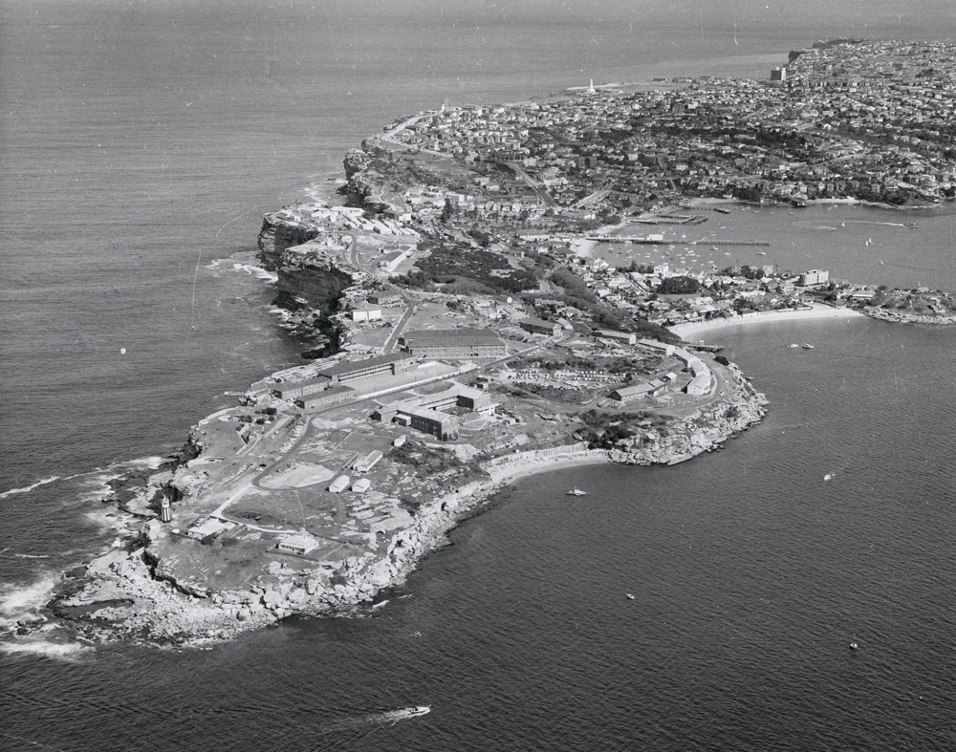

Meanwhile, the training of the volunteer Reserve Forces had continued as a separate program under the three existing branches: the RANR included officers and ratings who had volunteered to carry out regular periods of training in RAN ships and establishments; the RANR (Sea-going) branch consisted of officers holding Board of Trade Mercantile Certificates who were following the sea as a profession; while the RANVR was made up of officers and ratings who undertook to serve in case of emergency but who were unable to perform regular training.

In 1964 a new branch of the Reserves was established known as the Royal Australian Naval Emergency Reserve (RANER). It consisted of ex-RAN and trained RANR personnel who were prepared to make themselves available for immediate call-out in a situation of defence emergency short of war. In 1974 entry and enlistment in the RANER was suspended and the last sailor completed his engagement in 1979.

A further branch, the Royal Australian Fleet Reserve (RAFR), had existed since before WWII and consisted of ratings who had completed at least three years full-time service with the RAN or Royal Navy. Members served in the RAFR for engagements of five years and were liable for continuous service on mobilisation of the Citizen Naval Forces. The introduction of the Defence Force Retirement and Death Benefit (DFRDB) Act in 1973 significantly reduced the strength of RAFR since it removed the requirement for a sailor to enlist in the RAFR on completion of full-time service in order to qualify for an end-of-service bounty.

On 7 June 1973 the RANR (Sea-going) and the RANVR were absorbed into the RANR. RANR personnel at this time were attached to separate Port Divisions which existed in all capital cities and each of which was tasked with operating an attached training vessel and providing training for various specialist groups. At the height of their activity in the 1980’s, each Port Division had an attached Attack or Fremantle Class patrol boat, while Brisbane and Hobart respectively had a heavy landing craft and a general-purpose vessel. Some Port Divisions maintained up to three full sea-going crews for their attached vessel. The Port Divisions were largely self-administered with support provided from RAN training facilities.

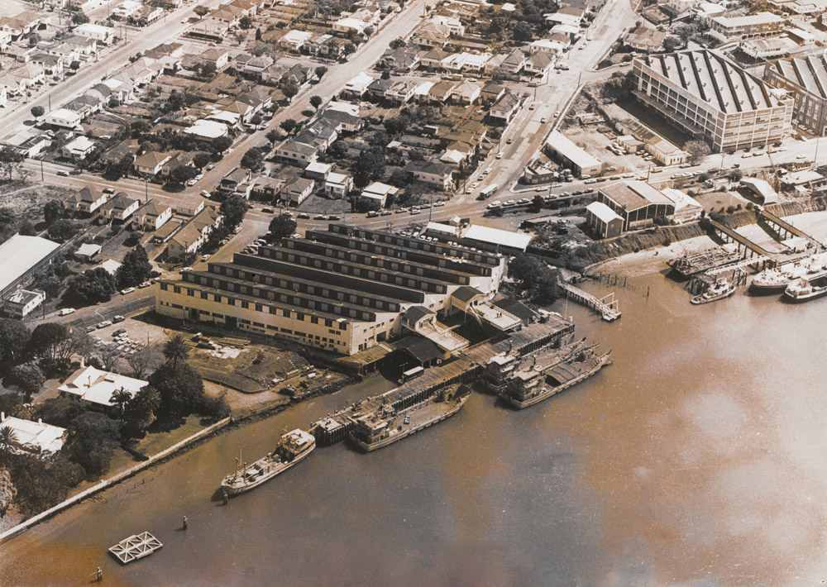

By the mid-1980s the Australian Naval Reserve had three component parts, two of which - officers on the Emergency List (RANEM) and sailors in the RAFR - comprised ex-permanent naval forces. But although these two components contributed over two-thirds of Australian Naval Reserve strength, they were largely latent forces with no training obligation. Administratively there were myriad different reserve categories and too many ineffective personnel on the many lists, while in structural terms the Reserves had been slow to evolve, and still reflected the requirement to man an expanded fleet in a general war. Government policy, however, sought the more effective employment of the Reserve forces in routine and contingent operations.

In 1986, the then Chief of Naval Staff, Vice-Admiral Michael Hudson, ordered the wearing of reserve insignia to be discontinued as a visible indication of the ‘All of One Company’ concept. In 1989, Vice Admiral Hudson accepted a Reserves Policy Paper which stressed the total Navy concept and further encouraged the explicit integration of the Reserve force within the broad context of the RAN’s roles. Integration resulted in the closure of the Port Divisions in the early 1990s and a subsequent decline in the number of ‘career reservists’ as personnel were increasingly sourced from ex-RAN members. The exceptions were generally those reservists who specialised as divers, musicians, naval control of shipping officers and intelligence officers, who continued to be recruited directly from civilian occupations.

In 1999, a final phase of integration was achieved with direct Permanent Naval Force (PNF) management of Reserves under national schemes of complement. This resulted in the Reserves being more accurately described as part-time members of the RAN rather than as a force brought together to provide a surge capability in times of defence emergency.

In 2005, the Naval Reserve comprised two lists of members - Active Reservists who were working part-time in the RAN and Standby Reserves who were available to work from time to time with the RAN but had no ongoing obligations to do so. Reservists came from all walks of life and from all parts of Australia. Some were former full-time RAN personnel while others had undertaken all their training on a part-time basis. Some Reserves worked in formed Reserve units, such as Diving Teams, Bands and Maritime Trade Operations; while others belonged to distinct Navy branches (Medical Officers, Seamen, Engineers) but worked individually in RAN ships or establishments alongside PNF personnel. The Director General Reserves - Navy headed the Reserve Directorate, at a national level, as part of Naval Headquarters.

Here are two of the Naval Vessels used by the Reserve. HMAS Bass and HMAS Castlemaine

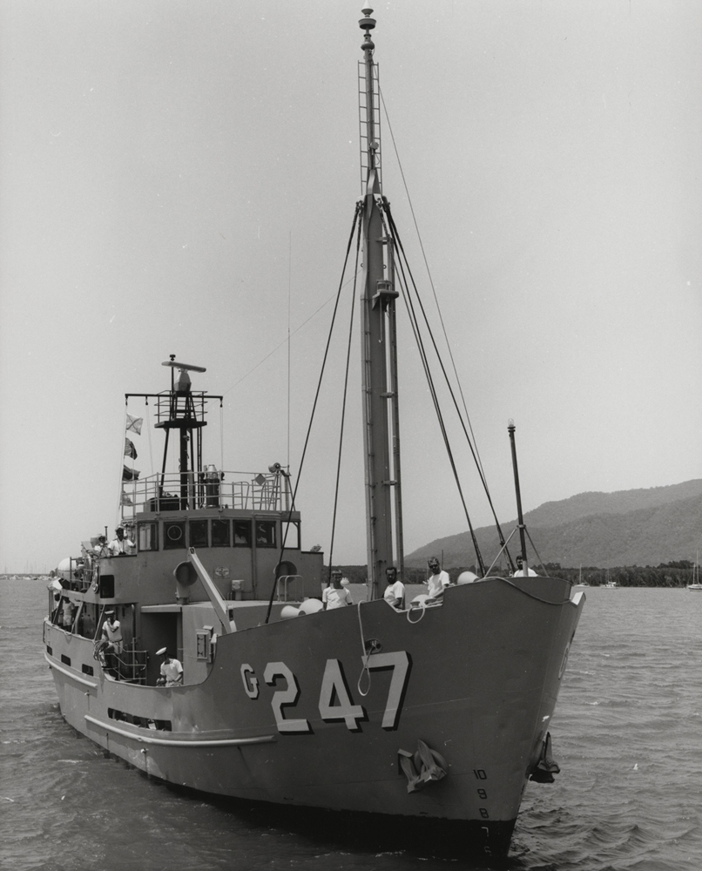

**Picture Funnies**

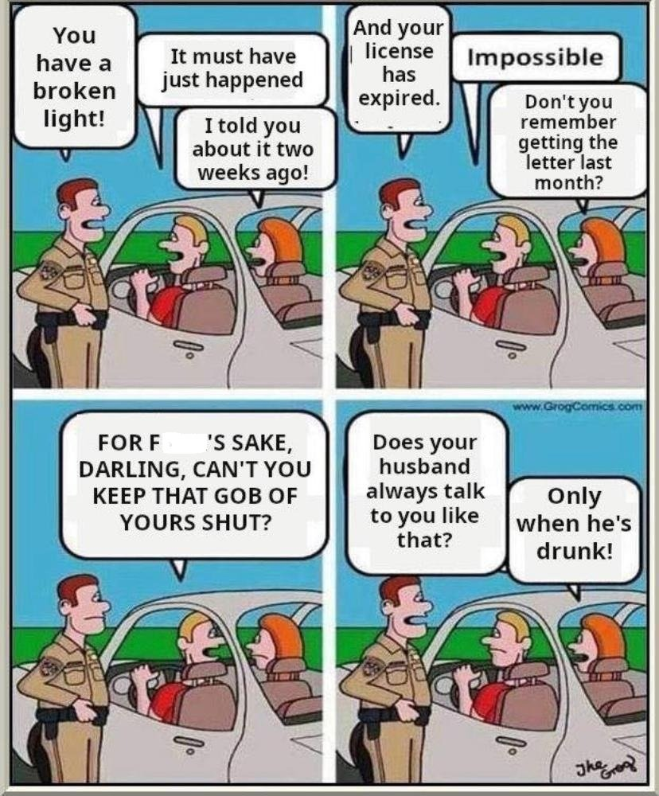



Naval Traditions- Terms – Slang

Rocky………………………. a reservist

Scab lifter……………………Medical sailor

Scran…………………………Food or meal served up.

Sculling………………………Things left lying around.

Sin Bosun……………………. Chaplain

Sky Pilot………………………Chaplain

Skulking………………………Knowingly avoiding work.

Soggies………………………. Cereals

Throw a Goffer………………..Salute

Tiddy Oggie…………………. Pastie

Train smash…………………. Breakfast dish (cheese and tomatoes)

Under armers…………………. Deodorant

Uppers…………………………Upper deck

Warm the bell…………………Be prepared for early departure.

Goffer…………………………Soft drink

Pit……………………………. Bed or Bunk

Rack…………………………. Bed or Bunk

Oppo…………………………. Friend

Pipe down……………………. Cease work for the day.

***************************