|  |
| --- |
| Saclip_image001  **GREENBANK NAA NEWSLETTER**  **GREY FUNNEL DITS**  *Disclaimer: The material contained in this publication is in the nature of entertainment for the members. Contributions are acknowledged, with thanks, from service organisations. The editor expressly Disclaims all and any liability to any person, whether an association member or not. Views expressed may not necessary be those held by the Executive or the members.*    flag A close up of a sign  Description generated with very high confidence |

*Editor: Tony Holliday* [*tonyholliday13@gmail.com*](mailto:tonyholliday13@gmaiul.com) *0403026916*

*S***eries No. 5 Date: Issue November 2022 No .11**

**GREENBANK Naval Association Subsection**

**EVENTS: November / December**

Tuesday 08 November 2022 Normal Meeting 1900-2100 RSL Rooms

Wednesday 30 November 2022 Executive Meeting 1000-1030 RSL Rooms

**Jack’s Memorial: November 2022.**

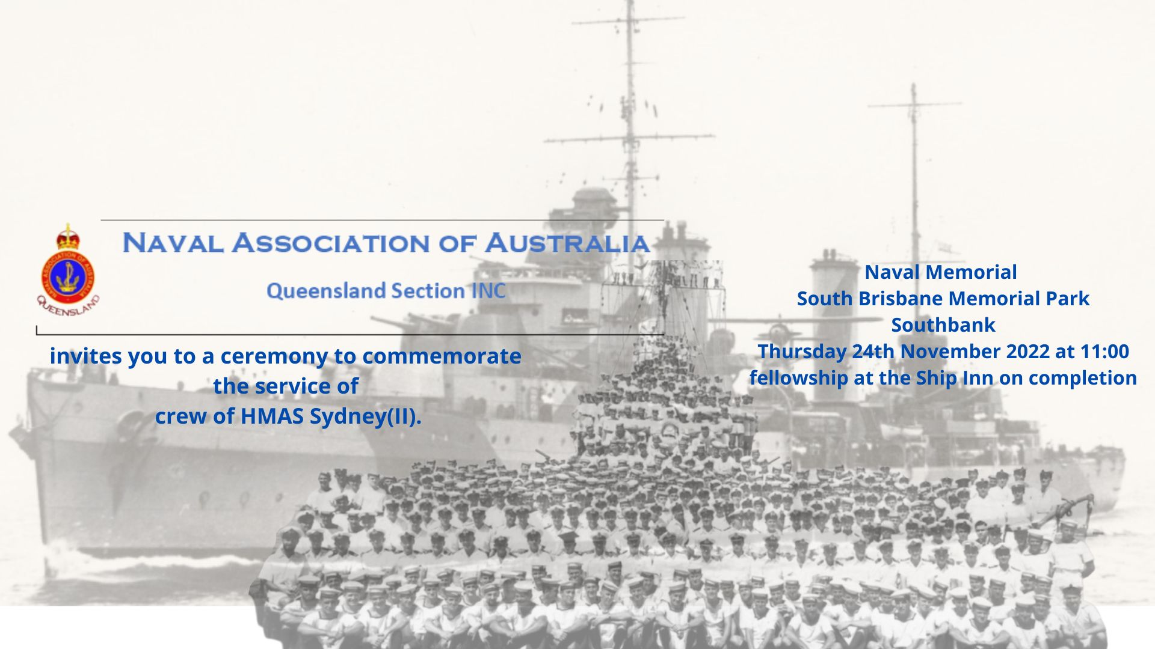

**ROYAL AUSTRALIAN NAVAL – Personality**

**LS P Tapim**

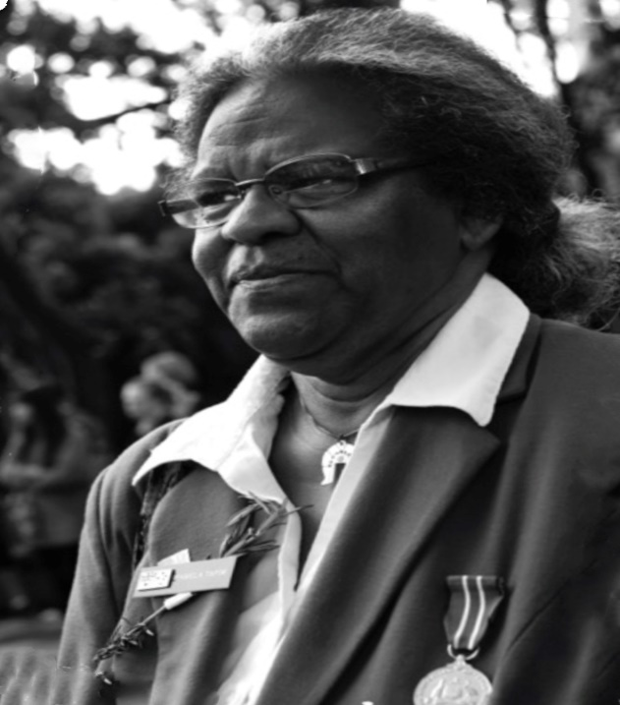Pamela Tapim joined the Womens Royal Australian Naval Service (WRANS) as a steward in Brisbane, Queensland on 6 November 1970.

Tapim's naval career began at HMAS *Cerberus*, where she undertook her initial training. A posting to HMAS *Harman* followed, where Tapim found herself serving in the wardroom as an officers steward. While in Canberra, Tapim would regularly visit Sydney to socialise, and it was there that she would meet her future husband Naval Airman Bob Tapim.

The couple were soon posted together to HMAS *Albatross*, where they spent the following twelve years.

Pamela Tapim discharged from the RAN and chose far north Queensland to settle and raise her family. She maintained a keen interest in the RAN's recruitment of Torres Strait Islander men and women through the [Defence Indigenous Development Program](https://www.video.defence.gov.au/APSCareers/Indigenous/ADF.asp).

**ROYAL AUSTRALIAN NAVY – Admirals**

**VADM. R G Taylor**

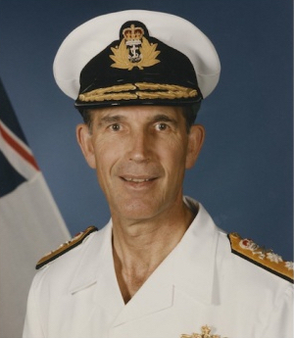**Rodney Graham Taylor** was born at Toowoomba, Queensland on 11 June 1940 and joined the RAN as a 13-year old junior entry cadet midshipman in 1954. He undertook his initial training at the Royal Australian Naval College at HMAS *Cerberus*, with further training as sea in HMAS *Swan*, at Britannia Royal Naval College, Dartmouth, and in HMAS *Quiberon*.

He served in numerous ships as a junior officer, including the Royal Yacht, HMY *Britannia*, later specialising in navigation. While serving as the navigating officer, in the guided missile destroyer HMAS *Brisbane* during her first deployment to Vietnam, he was mentioned in dispatches.

After promotion to Commander he commanded the Daring Class destroyer HMAS *Vampire* (1979-80) and then served at Fleet Headquarters as Commander (Plans) during 1980-81. As a Captain he commanded the destroyer escort HMAS *Torrens*and was also the Commander of the Third Australian Destroyer Squadron. Later he was appointed as Deputy Fleet Commander and Chief of Staff (1987-88), and subsequently was the inaugural Commodore Flotillas at Maritime Headquarters in Sydney (previous incumbents has been dual-hatted as Chief of Staff/Commodore Afloat). Here he was responsible for training and operational standards for the Fleet, which provided him with excellent background and experience for planning the RAN's participation in the First Gulf War (1990-91), following the invasion of Kuwait by Iraqi leader Saddam Hussein. At this time he was posted as Assistant Chief of Defence Force (Operations) at ADF Headquarters in Canberra, where he had carriage of the planning for Australia's wartime deployments to the Gulf region. He knew the precise capabilities of the ships committed to the Gulf deployments and equally understood the concerns of Maritime Headquarters. Later he became Deputy Chief of Naval Staff (1991-94) and was appointed as an Officer of the Order of Australia (AO) in 1992.

Taylor was promoted to Vice Admiral and appointed as Chief of Naval Staff in 1994, where he served with great distinction, overseeing considerable development and change within the Navy, when the first Anzac Class Frigate and Collins Class Submarine entered service. Feeling strong commitment to Navy's personnel, he continually stressed the importance of preserving Navy's values, traditions, ethos and professionalism. Under his leadership the Defence Efficiency Review was undertaken, which led to the subsequent Defence Reform Program. In early 1997 his title was amended to become Chief of Navy and he retired after 43 years of service shortly afterwards.

Vice Admiral Rodney Taylor passed away on 1 September 2002.

**GREAT WARSHIPS of WW11**

**KMS Scharnhoets**

*Scharnhorst and Gneisenau operated together for much of the early portion of*[*World War II*](https://en.wikipedia.org/wiki/World_War_II)*, including sorties into the Atlantic to raid British merchant shipping. During her first operation, Scharnhorst sank the armed merchant*[*HMS Rawalpindi*](https://en.wikipedia.org/wiki/HMS_Rawalpindi)*in a short engagement (November 1939). Scharnhorst and Gneisenau participated in*[*Operation Weserübung*](https://en.wikipedia.org/wiki/Operation_Weser%C3%BCbung)*(April–June 1940), the German invasion of Norway. During operations off Norway, the two ships engaged the battlecruiser*[*HMS Renown*](https://en.wikipedia.org/wiki/HMS_Renown_(1916))*and sank the*[*aircraft carrier*](https://en.wikipedia.org/wiki/Aircraft_carrier)[*HMS Glorious*](https://en.wikipedia.org/wiki/HMS_Glorious)*as well as her escort destroyers*[*Acasta*](https://en.wikipedia.org/wiki/HMS_Acasta_(H09))*and*[*Ardent*](https://en.wikipedia.org/wiki/HMS_Ardent_(H41))*. In that engagement Scharnhorst achieved one of the longest-range naval gunfire hits in history.*

*In early 1942, after British bombing raids, the two ships made the*[*Channel Dash*](https://en.wikipedia.org/wiki/Channel_Dash)*up the*[*English Channel*](https://en.wikipedia.org/wiki/English_Channel)*from occupied France to Germany. In early 1943, Scharnhorst joined the*[*Bismarck-class battleship*](https://en.wikipedia.org/wiki/Bismarck-class_battleship)[*Tirpitz*](https://en.wikipedia.org/wiki/German_battleship_Tirpitz)*in Norway to interdict Allied convoys to the*[*Soviet Union*](https://en.wikipedia.org/wiki/Soviet_Union)*. Scharnhorst and several*[*destroyers*](https://en.wikipedia.org/wiki/Destroyer)*sortied from Norway to attack a convoy but British naval patrols intercepted the German force. During the*[*Battle of the North Cape*](https://en.wikipedia.org/wiki/Battle_of_the_North_Cape)*(26 December 1943), the*[*Royal Navy*](https://en.wikipedia.org/wiki/Royal_Navy)*battleship*[*HMS Duke of York*](https://en.wikipedia.org/wiki/HMS_Duke_of_York_(17))*and her escorts sank Scharnhorst. Only 36 men survived, out of a crew of 1,968.*

**HAVE A LAUGH**

Here are some one liners:

* Which is faster, hot or cold? Hot, because you can catch cold.
* What did one plate say to the other plate? Dinner's on me.
* Why do oranges wear sunscreen? So they don't peel.
* My wife told me to stop acting like a flamingo, so I had to put my foot down.
* What do you call a pig that does karate? A pork chop.
* Where does Batman go to the bathroom? The batroom.
* What do you call a pony with a sore throat? A little horse.
* What did the left eye say to the right eye? Between you and me, something smells.
* What did the mama tomato say to the baby tomato? Catch up!
* Why didn't the melons get married? Because they cantaloupe.
* What do you call a fake noodle? An impasta.
* How did the pig get to the hogspital? In a hambulance.
* I'm so good at sleeping I can do it with my eyes closed!

**ROYAL AUSTRALIAN NAVY – Ship History**

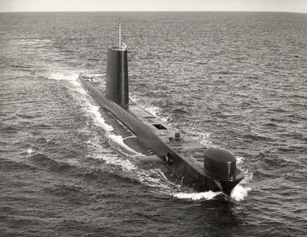**HMAS Ovens:**

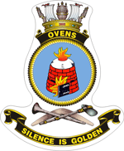

**HMAS *Ovens* was the third of six Oberon Class diesel electric patrol submarines built for the Royal Australian Navy at an initial cost of $9 million. The Oberon Class, or ‘O’ boats as they became known, were built by the Scott Shipbuilding and Engineering Company in Greenock, Scotland. Designed for quiet running, the Oberon’s were both anti-surface and anti-submarine vessels, capable of thirty-day patrol cycles. To remain submerged for lengthy periods a ‘snort’ system was incorporated into their design to allow batteries to be recharged and to expel stale air.**

**The first Australian Oberon class submarines provided the RAN with an anti-submarine warfare training platform, however, this soon changed to an operational role when their full potential as a patrol submarine, capable of operating virtually undetected for months at a time, was exploited.**

**HMAS *Ovens* was the third of six Oberon Class diesel electric patrol submarines built for the Royal Australian Navy at an initial cost of $9 million. The Oberon Class, or ‘O’ boats as they became known, were built by the Scott Shipbuilding and Engineering Company in Greenock, Scotland. Designed for quiet running, the Oberon’s were both anti-surface and anti-submarine vessels, capable of thirty-day patrol cycles. To remain submerged for lengthy periods a ‘snort’ system was incorporated into their design to allow batteries to be recharged and to expel stale air.The first Australian Oberon class submarines provided the RAN with an anti-submarine warfare training platform, however, this soon changed to an operational role when their full potential as a patrol submarine, capable of operating virtually undetected for months at a time, was exploited.**

**HMAS *Ovens* was launched at Greenock on 4 December 1967 by the Viscountess Slim and was commissioned on 18 April 1969. Sea acceptance and weapons trials commenced in May and on completion of these she began her maiden voyage to Australia arriving in Sydney on 17 October 1969. In April 1970, *Oven*s was one of an international fleet of 45 vessels that assembled in Sydney to commemorate the 200th anniversary of the landing on the east coast of Australia of the explorer Captain James Cook. This was followed by her participation in a variety of multinational exercises designed to forge closer regional links with Thailand, New Zealand and Singapore. In January 1972 she became the first RAN submarine to join the ANZUK force based in Singapore before returning to Australia in June that year.Between 10 September 1973 and 30 October 1975 *Oven*s was decommissioned and underwent her first major refit at Cockatoo Island Dockyard, Sydney.**

**Oberon Class submarine refits were complex in nature and involved removing the boat's 480 cell battery, accommodation fittings and all electrical and mechanical machinery with the exception of the main motors. Normally the submarine was placed on a slave dock where it would remain for approximately 60 weeks while the hull was examined for traces of corrosion before undergoing preservation. During that refit *Oven*s became the first of the RAN’s submarines to be fitted with a new long-range passive sonar system. Recommissioning on 31 October 1975, *Oven*s undertook a period of post refit trials before taking part in exercises off Australia’s east coast and deploying for Southeast Asia in May 1976.**

**Over the next four years *Oven*s continued to operate around the Australian coast and throughout the Pacific, participating in numerous regional exercises which saw her visit such places as New Zealand and Hawaii where she took part in the RIMPAC series of exercises. On 10 March 1980 *Oven*s ended her second commission when she was again taken into the hands of Cockatoo Island Dockyard for a major refit which included updating her weapons and sensors. That refit was adversely affected by a dockyard strike in August and September 1981and an ongoing campaign by dockyard employees for a shorter working week. consequently, *Oven*’s refit did not complete until 12 August 1982. Following a period of post refit trials, in company with HMAS *Hobart* and HMNZS *Otago*, *Oven*s returned to Sydney before sailing for sea acceptance trials in September 1982. With trials and a safety certification complete, *Oven*s underwent an inspection by the Fleet Commander on 12 October, while berthed alongside HMAS *Platypus*, which was followed by a rededication ceremony. During *Oven*’s third commission she regularly deployed throughout the Pacific and to Hawaii where she was a frequent visitor and participant in the RIMPAC exercises. She was awarded her Mk 48 torpedo weapons certification in 1982 and in November 1985 she conducted the first of the RAN’s sub-surface firings of the Harpoon anti-ship missile, scoring a direct hit on a distant, small remotely controlled surface target on the US Navy’s Pacific Missile Range Facility (PMRF), near Hawaii. In 1986, *Oven*s visited Melbourne as part of the Australian fleet’s visit to commemorate the 75th anniversary of the title ‘Royal’ being granted to the Australian Navy and shortly after deployed once again for Hawaii and participation in RIMPAC ’86. *Oven*s returned to Australia following brief goodwill visits to Apia and Fiji. During the next twelve months *Oven*s operated in Australian waters making numerous visits to local ports and participating in a broad range of exercises. In March 1987 she conducted a successful Mk 48 torpedo war-shot firing against the former RAN corvette HMAS *Colac* before deploying briefly to Western Australia. A visit to New Zealand followed in August before she returned to Sydney to prepare for her third and final major refit. *Oven*s was taken into the hands of Cockatoo Island Dockyard on 23 September 1987 and remained in refit until 11 April 1990.**

**During that time a significant work package was undertaken which included a rebuild of her communications centre, repairs to her pressure hull and conversion of her numbers 3 and 5 main ballast tanks. Soon after the completion of that refit, *Oven*s celebrated the 21st anniversary of her first commissioning and the following week 25 members of her crew represented the Australian Submarine Squadron in the 75th Anniversary Anzac Day march in Sydney. Post refit trials followed before *Oven*s again re-joined the fleet, where she participated in further exercises off the Australian coast.**

**In 1991 *Oven*s deployed for exercises with the United States Navy and Japanese Maritime Self Defence Force (JMSDF) in Asian waters where she visited Guam and Japan. Goodwill visits to Hong Kong and Singapore followed before she returned to Sydney in May for routine maintenance. The remainder of the year saw *Oven*s participating in exercises off the east coast of Australia with other Sydney based units of the RAN.1992 began with a safety assessment by the Submarine Sea Training Group, followed by workups and participation in Exercise KANGAROO 92 in waters off Darwin. The remainder of the year saw *Oven*s participate in further exercises off the eastern seaboard before sailing for Western Australia waters and deploying to Southeast Asia for Exercise STARFISH 92. Following brief goodwill visits to Singapore and Malaysia, *Oven*s returned to Western Australia where she called at Albany before transiting the Great Australian Bight and returning to Sydney in November. January 1993 began well for *Oven*s when she was awarded the Submarine Fighting Efficiency Shield and the Mk 48 Firing Proficiency Shield by the Maritime Commander Rear Admiral RAK Walls, AO, RAN. It was the third time that *Oven*s had won the Mk 48 Firing Proficiency Shield and an occasion that her crew were particularly proud of. Over the next six months *Oven*s was involved in local exercises and spent a brief period in the hands of Cockatoo Island Dockyard for a mid-cycle survey. This was followed by workups, an operational readiness evaluation, and passage to Southeast Asia, via Adelaide, for participation in Exercise STARFISH 93. Short visits to Singapore and Bali followed before *Oven*s returned to Sydney in October. The following year *Oven*s was involved in exercises off the east coast of Australia before deploying to Hawaii to participate in RIMPAC 94. Goodwill visits in the South Pacific were undertaken during her return voyage to Australia and in August she underwent a short period of maintenance in Sydney before undertaking trials off the NSW coast. A short deployment to Western Australian waters followed and while berthed at HMAS *Stirling* the boat was opened to inspection by visitors which proved very popular. *Oven*s' final year in commission began with routine exercises off the NSW coast followed by a brief visit to Newcastle and a deployment to New Zealand where she operated with ships of the Royal New Zealand Navy and French Navy.**

**On Friday 4 August 1995, *Oven*s sailed from HMAS *Platypus*, Sydney, for the last time to home port and decommission in Western Australia. Her departure from Sydney generated significant interest in the media and during her northerly voyage to Western Australia she called at Mackay, Townsville, Darwin, and Fremantle before arriving at HMAS *Stirling* on Monday 28 August. While in Fremantle she was opened to visitors and although it was not known at the time, this popular trend would continue when she was spared from the breakers yard to become a museum piece in Fremantle after decommissioning.**

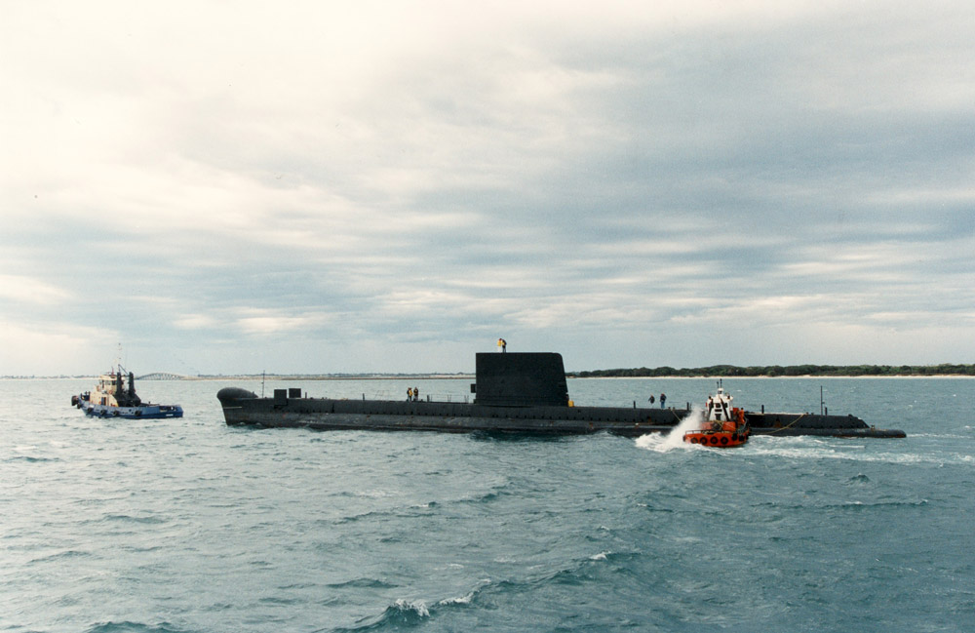

**ROYAL AUSTRALIAN NAVY – Active Fleet Ships**

**Minehunter Coastal (MHC)**

**HMAS Diamantina (lll)**

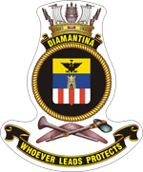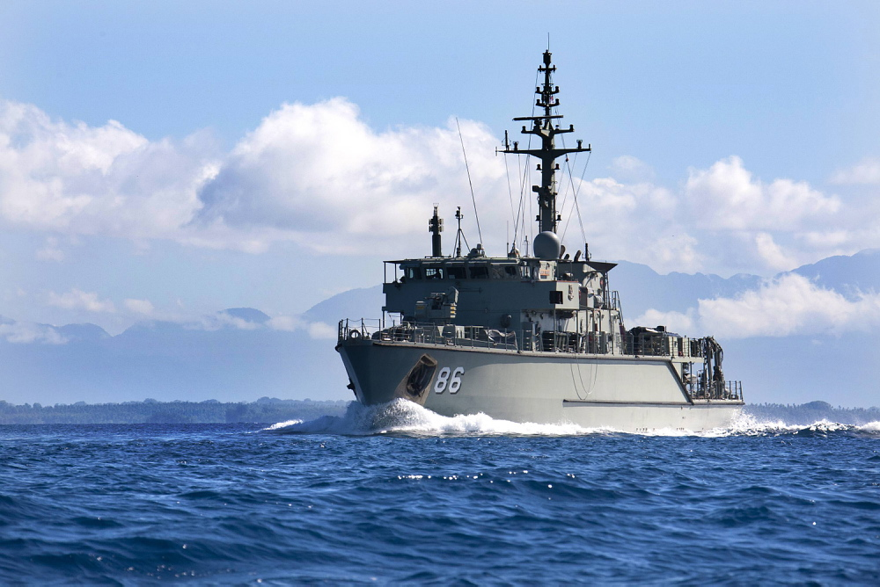

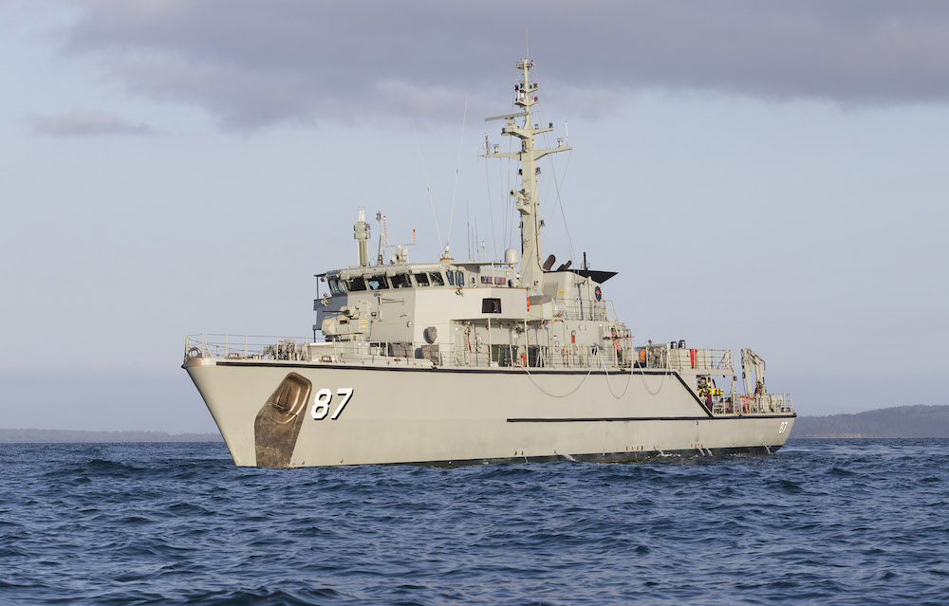**HMAS Yarra (IV)**

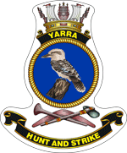

|  |  |  |  |
| --- | --- | --- | --- |
| Class | Huon Class | Displacement | 732 tonnes |
| Builder | ADI Newcastle | Length | 52.5Mtrs |
| Speed | 14 knots | Beam | 9.9Mtrs |
| Crew | 46 | Draught | 3Mtrs |
| Armament | 1 x MSI DS 30B 30mm | Machinery | 1 x Fincantieri diesel  3 x Fraschini 1300 Diesels  Riva Colxoni retractable/rotatable APU’s |

**These ships are the most advanced of its type in the world. These ships are made of fibre reinforced plastic and has a unique single skin solid hull that has no ribs or frames and provides high underwater shock resistance and very low magnetic and noise levels. This hull is designed to flex inwards if an undersea explosion occurs nearby. All machinery/equipment is mounted on cradles or suspended from bulkheads to further enhance resistance to shock damage and protect ship systems. The minehunter's principal task is to keep Australia's maritime focal points for trade free from the threat of mines. The ship uses high frequency sonar to search for, detect and then classify mine-like objects. Once detected, the ship deploys a remote controlled mine disposal vehicle or clearance divers to identify and, if necessary, neutralise the mine.**

**For their mine countermeasure operations, the ships are fitted with a Variable Depth Sonar capable of detection ranges in excess of 1,000 metres ahead of the ship. When a mine is detected in a water column or on the seabed, the ship will 'hover' about 200 metres from the contact. A mine disposal vehicle or clearance divers will then be sent to investigate and neutralise the mine threat. Each ship is fitted with a pair of electrically powered Bofors Underwater Systems Double Eagle mine disposal vehicles equipped with a searchlight, closed-circuit low light television camera and an on-board close range identification sonar. Commands are relayed via a fibre optic link inside the vehicle's tether, which also relays sensor images for display on the ship's multifunction console in the operations room.**

**Each Double Eagle vehicle is fitted with either a disposal charge slung beneath, or an explosive or mechanical cutter designed to sever the wire rope or chain holding moored mines.**

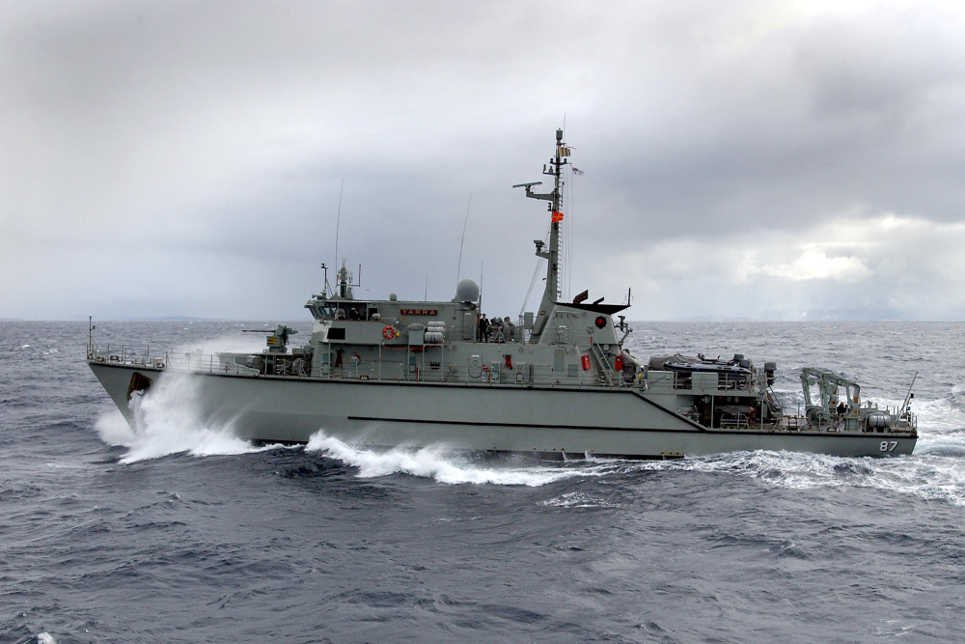

**PICTURE FUNNIES**

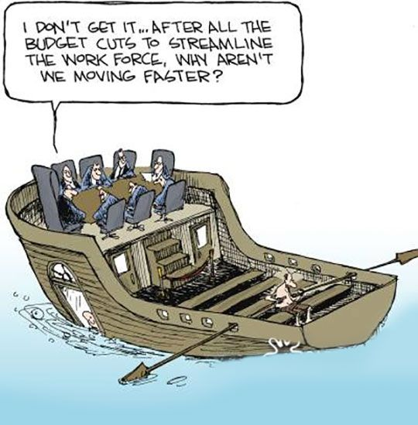

 

 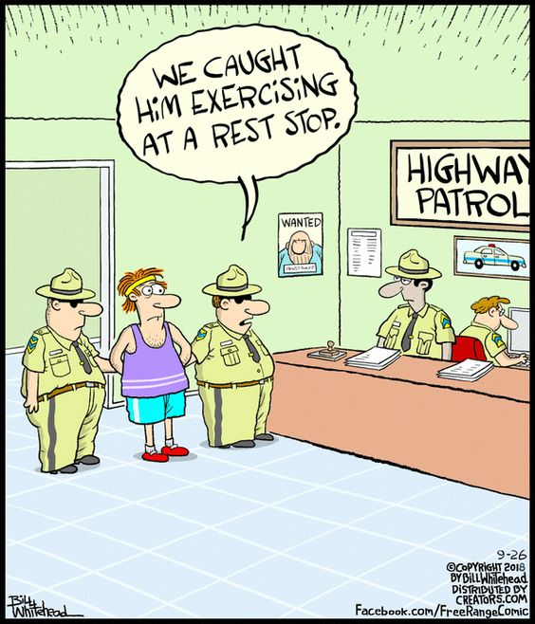

**NAVAL TRADITIONS – TERMS – SLANG**

**Naval slang:**

**Maccas: S**nacks or confectionary

**Maggot Bag:** Meat pie

**Oppo:** Friend or colleague

**Pay Off:** Discharge from navy

**Pipe Down:** Cease work for the day

**Pit:** Bed

**Rack:** Bed

**Redders:**  Tomato sauce

**Rocky**: Naval Reserve sailor

**Scab Lifter:** Medical sailor

**Scran:** Food or meal

**Sculling:** Anything left lying around

**Scribe:** A writer

**Sin Bosun:** A Naval Chaplain

**Skipper:** Captain of the ship

**Sky Pilot:** A Chaplain

**Soggies:** Cereals

**Throw a Goffer:** Salute

**Tiddley Oggie:** Pastie

**Under Armers:** Deodorant

**Uppers:** Upper deck of the ship

**Skulk:** Knowingly avoiding work

**Train Smash:** Breakfast dish made with Tomatoes and Cheese

**Warm the Bell:** Prepare for an early departure or end of a watch

**Stoker:** A Marine Technician (engine room sailor)

**Nick names:**

**Bell:** Dinga **Miller:** Dusty

**Bennett:** Wiggy **Moore:** Pony

**Brown:** Bomber **Murphy:** Spud

**Clarke:** Nobby **Neal:** Scratcher

**Evans:** Dorry **Payne:** Whacker

**Fleming:** Fluff **Parker:** Nosey

**Gale:** Windy **Patterson:** Banjo

**Gordon:** Flash **Reynolds:** Debbie

**Gray:** Dolly **Rodgers:** Buck

**Hill:** Windy **Smith:** Smouch

**Hudson:** Rock **Taylor:** Squizzy

**Jones:** Spike **Walker:** Phantom

**Lane:** Shady **Webb:** Spider

**Martin:** Pincher **White:** Knocker

**Metcalfe:** Chops **Wilson:** Tug

**Williams:** Bungy **Wright:** Shinner